Chapter 12. VLAN Trunking Protocol
This chapter covers the following key topics:
- Understanding VTP
Explains what VTP is and why it is used.
- VTP Modes
Compares and demonstrates VTP server, client and transparent modes.
- The Working Mechanics of VTP
Describes the various VTP messages such as summary and subset advertisements, advertisement requests, and pruning messages.
- Configuring VTP Mode
Provides various configuration examples that illustrate VTP operations and troubleshooting tools.
- VTP Pruning: Advanced Traffic Management
Explains how VTP pruning works, and how to configure it.
A number of Catalyst 5000/6000 features are specific to Cisco's LAN switching products. For example, this includes VLAN Trunking Protocol (VTP) described in this chapter as well as features described in other chapters. These features enhance how the Catalyst performs in the network and ease administrative burdens inherent in large LAN implementations. The Catalyst can operate without many, if not all, of the advanced features detailed in this and other chapters. You will, however, find administering and configuring your network cumbersome without them.
For example, the steps for creating a VLAN are to assign a Catalyst to a management domain, create the VLAN, and assign ports to the VLAN. One of the features covered in this chapter, VLAN Trunking Protocol (VTP), helps to minimize configuration efforts by helping with the first two steps. Without VTP, you need to perform these steps in every Catalyst in your network. With VTP, you only need to perform the first two steps at selected devices. This chapter details how VTP operates and how to configure it in your network and provides guidelines on when to exercise some of its features and when not to.
Dynamic VLANs are another feature intended to ease administrative burdens. Dynamic VLANs enable the Catalyst to configure ports to a VLAN automatically based upon the MAC address of the attached device. Chapter 5, "VLANs," covers dynamic VLANs and the VMPS server and client and details how to configure it.
Some advanced features in the Catalyst provide network performance enhancements by reducing the amount of flooded traffic in your network. A bridge deals with certain kinds of traffic, broadcast, multicast, and unknown unicast traffic, by flooding it throughout the bridged network. The Catalyst is a bridge, and, therefore, floods this traffic too. This chapter describes a mechanism for controlling flooded traffic in your network: VTP pruning. VTP pruning eliminates flooding by only flooding VLAN traffic over a trunk port if it needs to. VTP helps the Catalyst make the need to determination. This chapter describes the feature and details how to configure it on the 5000/6000 models.

Understanding VTP
VTP is a Cisco proprietary, Layer 2 multicast messaging protocol that can ease some of the administrative burden associated with maintaining VLANs. VTP maps VLANs across all media types and VLAN tagging methods between switches, enabling VLAN configuration consistency throughout a network. VTP reduces manual configuration steps required at each switch to add a VLAN when the VLAN extends to other switches in the network. Further, VTP minimizes potential configuration mismatches and manages the addition, deletion, and renaming of a VLAN in a more secure fashion than making manual changes at every switch. VTP is a value-add software feature specific to Cisco Catalyst switch products such as the 1900, 2820, 2948G, 3000, 4003, 5000 family, and 6000 family.
Not infrequently, users confuse the difference between VTP, ISL, 802.1Q, DISL, and DTP. All of these protocols involve trunks, but have different purposes. Table 12-1 compares these protocols.

Table 12-1. Summary of Trunk-Related Protocols
Protocol | Description
ISL | Cisco's proprietary trunk encapsulation method for carrying VLANs over FE or GE interfaces
802.1Q | An IEEE standard for carrying VLANs over FE or GE trunks that is essentially a subset of Cisco's current implementation of 802.1Q, which uses a Per-VLAN Spanning Tree implementation like ISL Trunk Protocol
DISL | Cisco's first generation trunk establishment protocol provides several options to enable the configuration of trunks at the other end of a switch link(s)
DTP | Cisco's second generation trunk establishment protocol establishes trunk negotiation options with links that may be using either 802.1Q or ISL as the trunk encapsulation type
VTP | Cisco's method of distributing VLAN information
ISL and 802.1Q specify how to encapsulate or tag data transported over trunk ports. The encapsulation and tagging methods identify a packet's source VLAN. This enables the switches to multiplex the traffic from multiple VLANs over a common trunk link. Chapter 8, "Trunking Technologies and Applications" describes these two methods and how they function.
DISL and DTP help Catalysts to automatically negotiate whether to enable a common link as a trunk or not. The Catalyst software included DISL until Cisco incorporated support for 802.1Q. When 802.1Q was introduced, the protocol needed to negotiate whether to use ISL or 802.1Q encapsulation. Therefore, Cisco introduced the second generation trunk negotiation protocol, DTP. DISL and DTP are described in Chapter 8.
VTP provides a communication protocol between Catalysts over trunks. The protocol allows Catalysts to share information about VLANs in the VTP management domain. VTP operates only after DISL/DTP complete the trunk negotiation process and functions as a payload of ISL/802.1Q. VTP does not work over non-trunk ports. Therefore, it cannot send/receive any messages until DISL or DTP negotiate a link into trunk status. VTP works separately from ISL and 802.1Q in that VTP messages transport configuration data, whereas ISL and 802.1Q specify encapsulation methods. If you have a protocol analyzer capable of decoding these protocols and set it up to capture trunk traffic, it displays VTP as encapsulated within an ISL or 802.1Q frame. Figure 12-12, discussed later in this chapter, shows a VTP frame encapsulated in ISL.
VTP primarily distributes VLAN information. You must configure VTP before you can configure any VLANs. Chapter 5 presented the three steps for creating a VLAN. Specifically, the steps include:
Step 1. Assign the Catalyst to a VTP domain (unless the Catalyst is configured in VTP transparent mode, discussed later.)
Step 2. Create the VLAN.
Step 3. Associate ports to the VLAN.
Chapter 5 described the details of the last two steps, but deferred the discussion about VTP domains to this chapter.
A VTP domain associates Catalysts with a common configuration interest. Catalysts within a VTP domain share VLAN information with each other. If an administrator on a Catalyst creates or deletes a VLAN, the other Catalysts in the VTP domain automatically become aware of the change in the list of VLANs. This helps to ensure administrative conformity between the Catalysts. Without configuration uniformity, Spanning Tree might not, for example, converge upon an optimal topology for the VLANs. VTP also serves to eliminate configuration steps for you. Without VTP, you need to manually create and delete VLANs in each Catalyst. But with VTP, VLANs automatically propagate to all other Catalysts throughout the VTP management domain. This is the principle benefit of VTP. Although this might not sound significant in a small network, it becomes particularly beneficial in larger networks.
A parallel benefit of the management domain limits the extent to which changes can be propagated. Figure 12-1 shows a Catalyst system with two management domains wally and world. Domain wally has VLANs 1, 2, 3, and 4 configured, and domain world has VLANs 1, 2, 3, and 10 configured. Assuming there are no Layer 3 issues, workstations assigned to the same VLAN can communicate with each other even though they are in different management domains. A station in VLAN 2 in wally belongs to the same broadcast domain as a station in VLAN 2 in world.

Figure 12-1 VLAN Distribution in a Catalyst Network
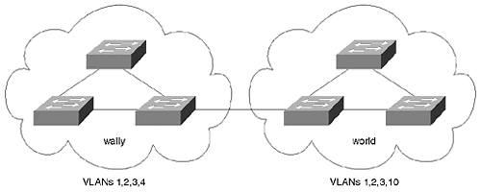
Suppose a network administrator decides to add a VLAN 5 to both domains. If you create VLAN 5 in wally, VTP propagates the new VLAN throughout the domain wally. When the VTP announcement reaches the border Catalyst in world, that Catalyst ignores the information from wally. The administrator needs to also create VLAN 5 in world to spread the VLAN existence.
Suppose the administrator decides to remove VLAN 3 from world. At a Catalyst in domain world, the administrator clears VLAN 3. What happens to VLAN 3 in wally? Nothing. When the border Catalyst in world advertises a VTP announcement to the Catalyst in wally, the wally border Catalyst ignores the information and retains VLAN 3.
Tip
In this case where the administrator deletes a VLAN, VTP propagates the deletion information to the other Catalysts in the management domain. Any hosts attached to ports in the deleted VLAN lose network connectivity because all Catalyst ports in the domain assigned to the VLAN become disabled.

At times, network administrators get new equipment. The equipment, of course, arrives with no configuration. But you cannot immediately start to create VLANs. You must first define a VTP domain. If your Catalyst is configured in the default server VTP mode and you do not assign a Catalyst to a VTP domain, the Catalyst does not let you create a VLAN as demonstrated in Example 12-1. Note that the Catalyst posts a message to the console stating that it refuses to change any VLAN status until it has a domain name. The message also references a VTP server. This is described in more detail later in the section "Configuring VTP Mode."

Example 12-1 Creating a VLAN with No VTP Domain Configured
Console> (enable) set vlan 10 name willitwork Cannot add/modify VLANs on a VTP server without a domain name. Console> (enable)
What constitutes a VTP domain? Three required conditions associate Catalysts to a common VTP domain:
- The Catalysts must have the same VTP domain name.
- They must be adjacent.
- Trunking must be enabled between the Catalysts.
The first prerequisite for VTP domain membership involves the management domain name. Catalysts identify their VTP management domain membership through the domain name. All Catalysts that you want to be in the same domain must have the same management domain name. Catalysts initially obtain their VTP management domain name either through command-line configuration or configuration file, or, if trunks are enabled, automatically from a neighbor Catalyst. To manually configure a Catalyst into a management domain, use the set vtp domain name command. Full usage is shown in Example 12-2.

Example 12-2 set vtp Usage
cat6> (enable) set vtp ? Usage: set vtp [domain <name>] [mode <mode>] [passwd <passwd>] [pruning <enable|disable>] [v2 <enable|disable> (mode = client|server|transparent Use passwd '0' to clear vtp password) Usage: set vtp pruneeligible <vlans> (vlans = 2..1005 An example of vlans is 2-10,1005)
The Catalyst accepts domain names up to 32 characters long. Example 12-3 shows a VTP domain name configuration example. The administrator configures the Catalyst as a member of the VTP domain wally.

Example 12-3 set vtp domain Example
Console> (enable) set vtp domain wally VTP domain wally modified Console> (enable)
What domain and VLAN do the Catalysts belong to when they have a clean configuration? If no VTP domain is assigned to the Catalysts, the domain is NULL. All ports belong to VLAN 1. Use the command show vtp domain any time to discover what VTP domain a Catalyst belongs to as illustrated in Example 12-4.

Example 12-4 show vtp domain Output
Console> (enable) show vtp domain Domain Name Domain Index VTP Version Local Mode Password -------------------------------- ------------ ----------- ----------- ---------- wally 1 2 server - Vlan-count Max-vlan-storage Config Revision Notifications ---------- ---------------- --------------- ------------- 5 1023 0 disabled Last Updater V2 Mode Pruning PruneEligible on Vlans --------------- -------- -------- ------------------------- 0.0.0.0 disabled disabled 2-1000 Console> (enable)
For example, in the highlighted portion of Example 12-4, the Catalyst's display indicates that it belongs to the domain wally. If the Domain Name field is blank, the domain is NULL.
Tip
VTP domain names are case sensitive. A VTP domain name San Jose is not the same as san jose. Catalysts with the former domain name cannot exchange VLAN configuration information with Catalysts configured with the later domain name.

As an example of how Catalysts obtain VTP membership, consider the Catalyst system in Figure 12-2 where multiple Catalysts interconnect over trunks, but no management domain is assigned.

Figure 12-2 A Catalyst VTP Domain Example
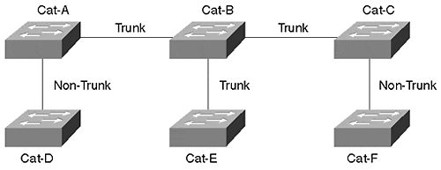
Cat-A, Cat-B, Cat-C, and Cat-E all have trunk connections to other Catalysts, whereas Cat-D and Cat-F only attach through access ports. This prevents Cat-D and Cat-F from receiving VTP messages from any of the other Catalysts. Entering the command show vtp domain reveals an output similar to that seen in Example 12-4, but with no domain name assigned on any unit. Assume that you attach to Cat-A's console port to make configurations, and you enter the command set vtp domain wally. What happens to the other Catalysts in the network? You examine the VTP status on each Catalyst with the show vtp domain command, and you discover that Cat-A, Cat-B, Cat-C, and Cat-E all learn about the management domain, but not Cat-D and Cat-F. Cat-D and Cat-F fail to learn about the management domain because they do not have trunk ports on which to receive VTP updates.
By setting the VTP domain in one unit, all other Catalysts attached with trunk ports automatically learn about VTP domain wally and configure themselves as part of the domain. This works because Cat-B, Cat-C, and Cat-E had trunk connections and did not already belong to a VTP domain. If however, you had previously associated them with a different domain, they would ignore the VTP announcement for wally.
At this point, you can create new VLANs in Cat-A, Cat-B, Cat-C, and Cat-E, but not Cat-D and Cat-F. You can only create VLANs in Catalysts configured with a VTP domain name (as mentioned earlier, this assumes the default setting of VTP Server Mode as discussed in the next section). Because D and F do not have a domain name, you cannot create VLANs in them. So how do you add VLANs to Cat-D and Cat-F? You need to manually enter a VTP domain name in these two units before you can create any VLANs in them. When you assign them to a domain, they do not make any VTP announcements because there is no trunk link. But they do belong to a management domain. Alternatively, you can enable the links between Cat-A and Cat-D and Cat-C and Cat-F as trunks. When they are enabled as trunks, Cat-D and Cat-F can then receive VTP updates and become members of the management domain wally.
The requirements for defining a VTP domain are listed earlier. One of the requirements is that Catalysts with the same VTP domain name must be adjacent to belong to the same management domain. In Figure 12-3, Catalysts interconnect with trunk links and belong to several management domains. Two of the domains have the same name, but are separated by other domains. Even though the Catalysts in the first and last domain have the same management domain name, they actually belong to two different domains from a system point of view.

Figure 12-3 A Multiple VTP Domain Network
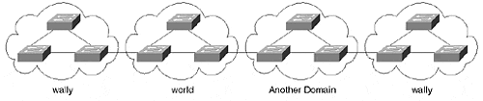
Whenever a Catalyst makes a VTP announcement, it includes the VTP domain name. If the receiving Catalyst belongs to a different management domain, it ignores the announcement. Therefore, VTP announcements from the wally domain on the left of the drawing are never seen by the Catalysts in the wally domain on the right of the drawing.
Tip
If you are installing a domain border switch that connects two domains, it becomes a member of the management domain that it first hears from. Therefore, be sure to attach it to the domain that you want it to belong to first. Make sure that it acquires the VTP domain name, and then attach it to the other domain. Otherwise, you need to manually configure the domain name.

Warning
A side effect of VTP domains can prevent an ISL trunk link from negotiating correctly with dynamic ISL (DISL). When DISL initiates trunk negotiation, it includes the VTP domain name in the message. If the two ends of the link belong to different domains, the trunk fails to establish automatically. To enable a trunk on border Catalysts between domains, set both ends of the trunk to ON or nonegotiate.

VTP Modes
Referencing the set vtp ? output of Example 12-2, notice that you have the option to configure a VTP mode. You can configure VTP to operate in one of three modes: server, client, or transparent. The three modes differ in how they source VTP messages and in how they respond when they receive VTP messages. Table 12-2 summarizes the differences between the three modes.

Table 12-2. VTP Mode Comparisons
Feature | Server | Client | Transparent
Source VTP Messages | Yes | Yes | No
Listen to VTP Messages | Yes | Yes | No
Create VLANs | Yes | No | Yes*
Remember VLANs | Yes | No | Yes*
*Locally significant only.

Source VTP Messages
Whenever you create a VLAN that you want VTP to automatically distribute to the other Catalysts in the management domain, you must create the VLAN on a Catalyst configured as a VTP server. After you create the VLAN, the VTP server automatically distributes the VLAN information through a VTP message called a VTP subset advertisement, which is described in more detail in the section, "Subset Advertisements." This message informs the other Catalysts in the management domain about the new VLAN. The Catalyst where you configure the new VLAN generates the initial subset advertisement which it sends out its trunk interfaces. Other servers and clients continue the propagation to other Catalysts in the network.
Catalysts configured in transparent mode, however, never generate VTP messages. When you create a VLAN on a transparent device, the VLAN information stays local and is not advertised to any other device—even if it has trunk connections to other Catalysts.

Listen to VTP Messages
Only Catalysts configured as server or client pay attention to VTP messages. Whenever they receive a message with the VTP multicast address 01-00-0C-CC-CC-CC and an SNAP type value of 0×2003, the receiving Catalyst sends the frame to the Supervisor module where it is processed. If the Supervisor determines that the information included in the update supercedes the information that it has, it updates the VLAN information and creates updated messages to other neighbor Catalysts. The Catalyst uses the VTP configuration revision number to recognize if it has older or current data. The configuration revision number usage is discussed later in this chapter.
When a Catalyst configured in transparent mode receives a VTP update, the Catalyst does not send the frame to the Supervisor. Rather, it locally ignores the frame. If, however, the Catalyst has other trunk links connected, it floods the frame out the other trunk ports. But the VTP message does not change the transparent Catalyst's configuration as it does for a server or client device.

Create VLANs
If you desire to create a VLAN, you must create it on a Catalyst configured in server or transparent mode. These are the only modes authorized to accept set vlan and clear vlan commands. The difference between them, though, is the behavior after you create the VLAN. In the case of the server mode, the Catalyst sends VTP advertisements out all trunk ports to neighbor Catalysts. Transparent mode Catalysts do not issue any type of VTP announcement when a VLAN is created. The new VLAN is only locally significant. If you build an entire network with Catalysts configured in transparent mode, you need to create new VLANs in each and every Catalyst as an individual command. Catalysts in transparent mode do not, for all intents and purposes, participate in VTP. To them, it is as if VTP does not exist. You do not need to assign the transparently configured Catalyst to a VTP domain before you can create any local VLANs. VTP transparent mode switches do not advertise changes or additions made for VLANs on the local switch, but they pass through VLAN additions or changes made elsewhere.
Catalysts configured as clients do not have the authority to create any VLANs. If you associate a client port to a VLAN that it does not know about, the Catalyst generates a message informing you that you must create a VLAN on a server before it can move the ports to the VLAN. If, after assigning the ports to the VLAN, you look at the VLAN status with the show vlans command, you might notice that the ports belong to the new but non-existent VLAN and are in a suspended state preventing the forwarding of frames in the VLAN. When you actually create the VLAN on a server in the same management domain as the client, the client eventually hears about the new VLAN and interprets this as authorization to activate ports in the new VLAN.
Similarly, you cannot delete VLANs in a client, only in a server or transparent device. Deleting a VLAN in a transparent device only affects the local device as opposed to when you delete a VLAN from a server. When deleting a VLAN from a server, you get a warning message from the Catalyst informing you that this action places any ports assigned to the VLAN within the management domain into a suspended mode, as shown in Example 12-5.

Example 12-5 Clearing a VLAN in a Management Domain
Console> (enable) clear vlan 10 This command will deactivate all ports on vlan 10 in the entire management domain Do you want to continue(y/n) [n]?y Vlan 10 deleted Console> (enable)
Tip
Clearing a VLAN does not cause the ports in the management domain to reassign themselves to the default VLAN 1. Rather, the Catalysts keep the ports assigned to the previous VLAN, but in an inactive state. You need to reassign ports to an active VLAN before the attached devices can communicate again.

Remember VLANs
Whenever you create, delete, or suspend a VLAN in a server or transparent Catalyst, the Catalyst stores the configuration information in NVRAM so that on power up it can recover to the last known VLAN configuration. If the unit is a server, it also transmits configuration information to its Catalyst neighbors.
Clients, on the other hand, do not store VLAN information. When a Catalyst configured in client mode loses power, it forgets about all the VLANs it knew except for VLAN 1, the default VLAN. On power up, the client cannot locally activate any VLANs, except VLAN 1, until it hears from a VTP server authorizing a set of VLANs. Any ports assigned to VLANs other than VLAN 1 remain in a suspended state until they receive a VTP announcement from a server. When the client receives a VTP update from a server, it can then activate any ports assigned to VLANs included in the VTP announcement.

VTP VLAN Distribution Demonstrated
Consider Figure 12-4 to illustrate the differences between a server (Cat-A), client (Cat-C), and transparent (Cat-B) configuration, where one of each is linearly cascaded with a transparent device (Cat-B) in the middle.

Figure 12-4 VLAN Distribution for VTP Modes Server, Client, and Transparent
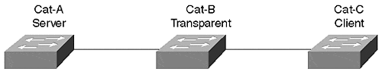
Table 12-3 shows the starting condition and all subsequent conditions for Catalysts A, B, and C.

Table 12-3. Status for Catalysts in Figure 12-4 Demonstrating Server, Client, and Transparent Mode
 |  | Configured VLANs for:
Step # | Event | Cat-A  Server | Cat-B  Transparent | Cat-C  Client
1 | Starting Condition. | 1 | 1 | 1
2 | Create VLAN 2 in Cat-C. | 1 | 1 | 1
3 | Assign ports to VLAN 2 in Cat-C. | 1 | 1 | 1
4 | Create VLAN 2 in Cat-A. | 1, 2 | 1 | 1, 2
5 | Create VLAN 10 in Cat-B. | 1, 2 | 1, 10 | 1, 2
6 | Lose and restore power on Cat-A and Cat-B. | 1, 2 | 1, 10 | 1, 2
7 | Lose power on Cat-A and Cat-C. Restore power to Cat-C only. | N/A | 1, 10 | 1
8 | Restore power on Cat-A. | 1, 2 | 1, 10 | 1, 2
9 | Create VLAN 20 on all three Catalysts. | 1, 2, 20 | 1, 10, 20 | 1, 2, 20
In the starting configuration of Step 1, the Catalysts have a VTP domain name assigned to them. In reality, VTP in Cat-B isn't really participating and can be ignored for now. All three Catalysts start with only the default VLAN 1. In Step 2, the administrator starts work on the client and tries to create a new VLAN. But because Cat-C is a client, Cat-C rejects the command, posts an error to the console, and does not create any new VLAN. Only VLAN 1 remains in existence. The administrator assigns ports to VLAN 2 in Step 3 with the set vlan command. Even though VLAN 2 does not exist yet, Cat-C accepts the port assignment, moves ports to VLAN 2, and places them in the suspend state. However, Cat-C only knows about VLAN 1.
In Step 4, the administrator moves to Cat-A, a server, and creates VLAN 2 which then gets propagated to its neighbor, Cat-B. But Cat-B, configured in transparent mode, ignores the VTP announcement. It does not add VLAN 2 to its local VLAN configuration. Cat-B floods the VTP announcement out any other trunk ports to neighbor Catalysts. In this case, Cat-C receives the VTP update, checks the VTP management domain name, which matches, and adds VLAN 2 to its local list. Cat-C then activates any ports assigned to VLAN 2. Any devices attached to ports in VLAN 2 on Cat-A now belong to the same broadcast domain as ports assigned to VLAN 2 on Cat-C. If Layer 3 permits, these devices can now communicate with each other.
The administrator now moves (or Telnets) to Cat-B in Step 5 and creates a new broadcast domain, VLAN 10. As a Catalyst configured in transparent mode, the Catalyst is authorized to create VLAN 10. But Cat-B does not propagate any information about VLAN 10 to the other Catalysts. VLAN 10 remains local to Cat-B and is not a global VLAN.
A disaster occurs in Step 6 when the facility loses power to Cat-A and Cat-B. But, because you are a savvy network engineer, you configured them in server and transparent modes so they can remember their VLAN configuration information. Although Cat-A and Cat-B remain without power, Cat-C continues to operate based upon the last VLAN configuration it knew. All ports on Cat-C remain operational in their assigned VLANs. When power is restored to Cat-A and Cat-B, both Catalysts remember their authorized VLANs and enable them. Cat-A also issues VTP messages to neighbors. This does not affect the operations of Cat-B or Cat-C, though, because they both remember their configuration.
Now consider what happens if Cat-A and Cat-C lose power. In Step 7, this occurs, but power is restored to Cat-C before Cat-A. When Cat-C recovers, it starts with only VLAN 1 authorized. Ports in any other VLAN are disabled until Cat-C hears a VTP message from a server. If Cat-A takes one hour to recover, Cat-C remains in this state the entire time. When Cat-A finally restarts in Step 8, it sends VTP messages that then authorize Cat-C to enable any ports in VLANs included in the VTP announcement.
Finally, the administrator creates another VLAN for the entire management domain. In Step 9, the administrator creates VLAN 20. But this takes two configuration statements. The administrator must create the VLAN in Cat-A and in Cat-B. Now there are two global VLANs in the domain. Any devices in VLAN 20 belong to the same broadcast domain, regardless of which Catalyst they connect to. VLAN 1 is the other global broadcast domain. Any devices in VLAN 1 can also communicate with each other. But, devices in VLAN 1 cannot communicate with devices in VLAN 20 unless there is a router in the network.

The Working Mechanics of VTP
The VLAN Trunking Protocol developed by Cisco operates as a Layer 2 protocol for Catalyst products. When transmitting VTP messages to other Catalysts in a network, a Catalyst encapsulates the VTP message in a trunking protocol frame, such as ISL or 802.1Q. Figure 12-5 shows the generic encapsulation for VTP within an ISL frame. The ISL encapsulation starts with the header information detailed in Chapter 8, "Trunking Technologies and Applications." The VTP header varies depending upon the type of VTP message discussed, but generally, four items are found in all VTP messages:

Figure 12-5 VTP Encapsulation over ISL Trunks
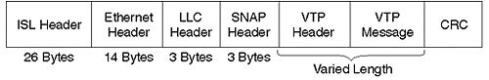
- VTP protocol version—
Either version 1 or 2
- VTP message type—
Indicates one of four types
- Management domain name length—
Indicates the size of the name that follows
- Management domain name—
The name configured for the management domain
Additional details on the VTP messages are in the following sections. VTP messages always travel over the default VLAN for the media. For example, on an Ethernet trunk, VTP transports over VLAN 1; on FDDI, it transports over VLAN 1002; and over ATM, VTP transports over ELAN default. Because you cannot delete any of the default VLANs, VTP messages always propagate over LAN trunk ports. However, VTP does not always transport over ATM trunks. ELAN default must be enabled for VTP to cross ATM. But, this ELAN does not automatically exist. You must explicitly enable this ELAN if you want VTP messages to cross the ATM link.
Although Cisco routers understand trunking protocols like ISL, LANE, and 802.1Q, they currently do not participate in VTP; routers ignore VTP messages and discard them at the router interface. Therefore, VTP messages propagate no further than a router interface, or to another Catalyst that belongs to a different VTP management domain. Figure 12-6 shows a system with three management domains isolated through varied domain assignments and through a router. Domain 1 has three management domain border points, one to the router and two into Domain 2.

Figure 12-6 VTP Boundaries
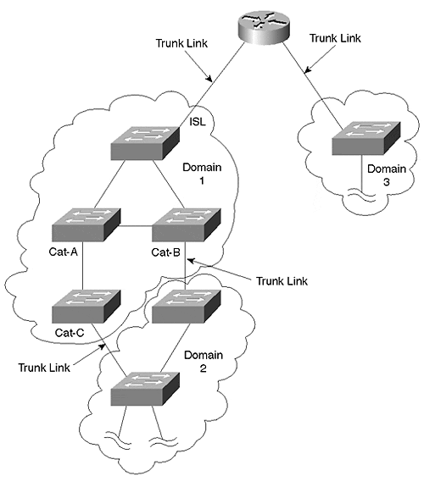
When Cat-A in Domain 1 issues a VTP message, the message gets distributed to all of the other Catalysts in the domain. Cat-B and Cat-C receive the message and forward it to the two Catalysts in Domain 2. However, these Catalysts see that the source domain differs from their own and, therefore, discard the VTP message.
The VTP message generated in Domain 1 also propagates to the router. But the router does not participate with VTP and discards the message.
Likewise, VTP messages generated in Domain 2 or Domain 3 never affect devices outside of their domain.
VTP defines four message types:
- Summary advertisements
- Subset advertisements
- Advertisement requests
- VTP join messages
The first three message types describe interactions between VTP servers and clients for the distribution of VLAN information. These messages occur by default whenever you enable a trunk between Catalysts configured as servers and/or clients. The fourth message is disabled by default and is only enabled whenever you turn on VTP pruning. The section in this chapter, "VTP Pruning: Advanced Traffic Management," describes VTP pruning; therefore, the discussion on the fourth message type is deferred until then.

VTP Configuration Revision Number
Whenever you make a VLAN change on a server Catalyst, the Catalyst issues VTP messages so that other Catalysts can update their VLAN configurations. It is, however, important that the Catalysts keep track of what information is newer than others. Therefore, VTP keeps a configuration revision number that increments whenever you add, delete, or suspend a VLAN. Catalysts in a management domain compare the revision number to determine if the announcement contains newer or obsolete information.
With a fresh configuration, the Catalyst has a revision number of zero. The revision number in the management domain continues to increment until it reaches 2,147,483,648, at which point the counter wraps back to zero.
Tip
You can quickly and easily reset the configuration revision number with the set vtp domain name command. Changing the domain name sets the configuration revision number to zero. Or, you can make 2,147,483,684 VLAN changes to your system to force the counter to roll back to zero. Unfortunately, this could take a very long time to accomplish.

Summary Advertisements
By default, server and client Catalysts issue summary advertisements every five minutes. Summary advertisements inform neighbor Catalysts what they believe to be the current VTP configuration revision number and management domain membership. The receiving Catalyst compares the domain names and, if they differ, ignores the message. If the domain names match, the receiving server or client Catalyst compares the configuration revision number. If the advertisement contains a higher revision number than the receiving Catalyst currently has, the receiving Catalyst issues an advertisement request for new VLAN information.
Figure 12-7 shows the protocol format for a summary advertisement.

Figure 12-7 VTP Summary Advertisement Format
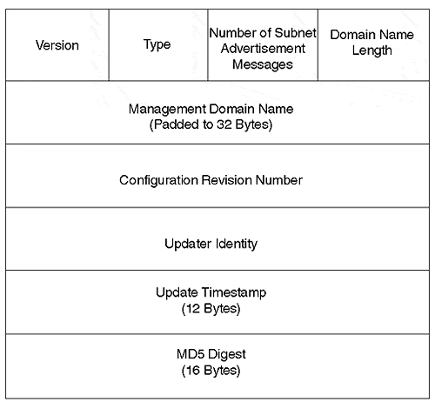
Each row in Figure 12-7 is four octets long. The Version, Type, Number of Subnet Advertisement Messages, and Domain Name Length Fields are all one octet long. Some of the fields can extend beyond four octets and are indicated in the figure. A description of each of the fields follows the decode in Figure 12-8.
Figure 12-8 decodes a summary advertisement packet encapsulated in an ISL trunking protocol frame. If the trunk uses 802.1Q rather than ISL, the VTP message is exactly the same, only encapsulated in an 802.1Q frame.

Figure 12-8 VTP Summary Advertisement Analyzer Decode
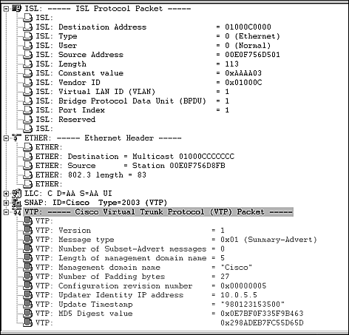
The decode starts with the SNAP header that follows the other headers shown in Figure 12-5. Although VTP uses the same Ethernet multicast address as CDP, the SNAP value differs between the two. CDP uses a SNAP value of 0x2000, but VTP uses a SNAP value of 0x2003. This allows the receiving Catalysts to distinguish the protocols.
The VTP header contains the VTP version in use. All Catalysts in the management domain must run the same version. In this case, they are running VTP version 1. If there are Token Ring switch ports in your domain, this would have to be VTP version 2. The message type value indicates which of the four VTP messages listed earlier was transmitted by the source Catalyst.
The following field, Number of Subset Advertisement Messages, indicates how many VTP type 2 messages follow the summary advertisement frame. This value can range from zero to 255. Zero indicates that no subset advertisements follow. A Catalyst only transmits the subset advertisement if there is a change in the system, or in response to an advertisement request message.
The domain length and name follows this field along with any padding bytes necessary to complete the Domain Name field.
The source also transmits the VTP configuration revision number and identifies itself through its IP address. Remember from the earlier section, "VTP Configuration Revision Number," that the receiving Catalyst compares the configuration revision number with its internal number to determine if the source has new configuration information or not.
The message includes a timestamp which indicates the time the configuration revision number incremented to its current value. The timestamp has the format of yymmddhhmmss which represents year/month/day and hour/minute/second.
Finally, the source performs an MD5 one-way hash on the header information. An MD5 (message digest type 5) hash algorithm is frequently used in security systems as a non-reversible encryption process. The receiving Catalyst also performs a hash and compares the result to detect any corruptions in the frame. If the hashes do not match, the receiving Catalyst discards the VTP message.

Subset Advertisements
Whenever you change a VLAN in the management domain, the server Catalyst where you configured the change issues a summary advertisement followed by one or more subset advertisement messages. Changes that trigger the subset advertisement include:
- Creating or deleting a VLAN
- Suspending or activating a VLAN
- Changing the name of a VLAN
- Changing the MTU of a VLAN
Figure 12-9 shows the VTP subset advertisement packet format.

Figure 12-9 VTP Subset Advertisement Format
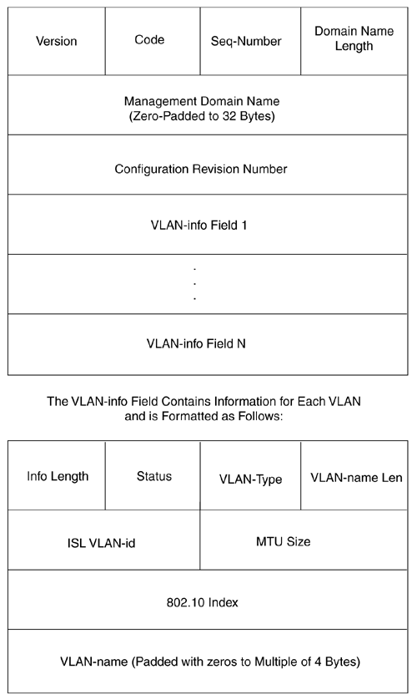
The summary advertisement has a Seq-Number field in the header indicating the number of subset advertisements that follow. If you have a long VLAN list, VTP might need to send the entire list over multiple subset advertisements.
Figure 12-10 shows a subset advertisement (partial listing). As with the summary advertisement, the message includes the VTP version type, the domain name and related fields, and the configuration revision number. The header sequence number indicates the identity of the subset advertisement. If multiple subset advertisements follow the summary advertisement, this number indicates the subset instance sent by the updater. The sequence numbering starts with 1. The receiving Catalyst uses this value to ensure that it receives all subset advertisements and, if not, can request a resend starting with a specific subset advertisement.

Figure 12-10 VTP Subset Advertisement Analyzer Decode
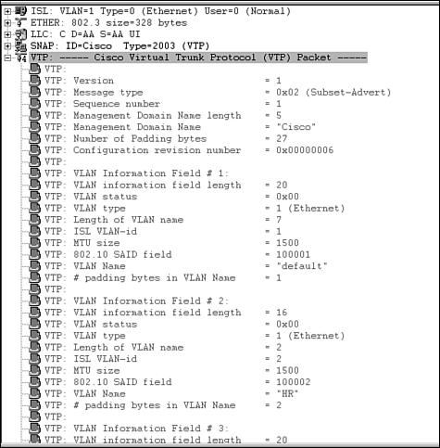
The summary advertisement then lists all of the VLANs in the management domain along with the following information for each:
- Length of the VLAN description field
- Status of the VLAN. The VLAN can be active or suspended
- VLAN type. Is it Ethernet, Token Ring, FDDI, or other?
- MTU (maximum transmission unit) for the VLAN. What is the maximum frame size supported on this VLAN?
- Length of the VLAN name
- The VLAN number for this named VLAN
- The SAID value to use if the frame is passed over an FDDI trunk
- The VLAN name
The VTP subset advertisement individually lists this information for each VLAN, even the default VLANs.

Advertisement Requests
A Catalyst issuing the third VTP message type, an advertisement request, solicits summary and subset advertisements from a server in the management domain. Catalysts transmit an advertisement request whenever you reset the Catalyst, whenever you change its VTP domain membership, or whenever it hears a VTP summary advertisement with a higher configuration revision number than it currently has. This can happen if a Catalyst is temporarily partitioned from the network and a change occurs in the domain.
Figure 12-11 shows a VTP advertisement request frame format.

Figure 12-11 VTP Advertisement Request Format
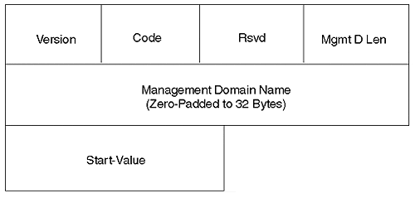
An advertisement request includes six fields. The Version field identifies the VTP version used by the device. The Code field identifies this as an advertisement request. The reserved (Rsvd) portion is set to zero. The Management Domain Length field (MgmtD Len) indicates the length of the domain name in the following field. These four fields are followed by the Management Domain Name. Finally, if the Catalyst expected to receive subset advertisements but failed to receive one or more, it can request a resend starting at a particular subset instance value. This is signaled in the Start-Value field. For example, if the Catalyst expected to see three subset advertisements but only received instances 1 and 3, it can request a resend starting at instance 2.
Figure 12-12 shows an advertisement request captured on an analyzer.

Figure 12-12 VTP Advertisement Request Analyzer Decode
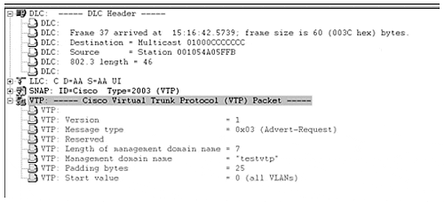
The advertisement request in Figure 12-12 requests all subset advertisements for the management domain testvtp. This is recognized because the start value is zero.

Configuring VTP Mode
Use the set vtp mode {server|client|transparent} to define the Catalyst's VTP mode. You have the option to specify the VTP mode when you specify the VTP domain name. If you do not specify a VTP mode, server is defined as the default.
Example 12-6 shows output for configuring a Catalyst into the client mode. Note the highlighted portion of the output indicating that the Catalyst is now configured as a client.

Example 12-6 Setting VTP Mode to Client
Console> (enable) set vtp mode client VTP domain wally modified Console> (enable) show vtp domain Domain Name Domain Index VTP Version Local Mode Password -------------------------------- ------------ ----------- ----------- ---------- wally 1 2 client - Vlan-count Max-vlan-storage Config Revision Notifications ---------- ---------------- --------------- ------------- 10 1023 40 enabled Last Updater V2 Mode Pruning PruneEligible on Vlans --------------- -------- -------- ------------------------- 10.0.0.1 disabled disabled 2-1000 Console> (enable)
As illustrated in the section on decoding VTP subset advertisements, all VLAN information sent over the wire is cleartext. Anyone with an analyzer package can capture the VTP frame and decode it. A system attacker can use this information to disrupt your network. For example, an attacker can fabricate a false subset advertisement with a higher configuration revision number and delete the VLANs in your management domain.
As a security option, you can specify a password for VTP subset advertisements. If you specify a password, the Catalyst uses this as a key to generate an MD5 hash. Whenever a source Catalyst issues a subset advertisement, it calculates the hash for the advertisement message and uses the password as the key. VTP includes the hash result in the subset advertisement. The receiving Catalyst must also have the same password locally configured. When it receives the subset advertisement, it generates a hash using its password and compares the result with the received message. If they match, it accepts the advertisement as valid. Otherwise, it discards the subset advertisement.
You can configure a password using the command set vtp passwd passwd.

Tracking VTP Activity
The command show vtp statistics is a particularly useful command for tracking VTP activity such as the number and type of VTP messages sent and received from a Catalyst. Example 12-7 shows typical show vtp statistics output.

Example 12-7 show vtp statistics Screen
Cat-A > (enable) show vtp statistics VTP statistics: summary advts received 5392 subset advts received 16 request advts received 3 summary advts transmitted 5280 subset advts transmitted 7 request advts transmitted 0 No of config revision errors 0 No of config digest errors 0 VTP pruning statistics: Trunk Join Trasmitted Join Received Summary advts received from non-pruning-capable device -------- --------------- ------------- --------------------------- 1/1 0 0 0 1/2 0 0 0 Cat-A > (enable)
Notice the highlighted line in Example 12-7. It lists the number of incidents where the received MD5 hash did not match the locally calculated value. This can indicate either a corruption of the frame from a physical layer problem or a security issue. If the problem stems from a physical layer issue, you might anticipate that other frames also have problems. If you do not experience other transmission errors, there might be an attack where the attacker is attempting to spoof a Catalyst and corrupt your management domain.

VTP: A Good or Bad Thing?
One of the primary advantages of VTP is its capability to distribute VLANs to other Catalysts to simplify your configuration tasks. As a result of VTP, you do not need to type the set vlan command nearly as often as you do without it. You only need to create the VLAN once in the management domain rather than at each switch. But, you still need to do a set vlan command to add the ports that will be assigned to that VLAN on a given switch. Deleting a VLAN in a domain is also easy because you only need to do it at one location.
However, there are some disadvantages to VTP and trunking that you need to consider as discussed in the sections that follow.

VLAN Table Deletion
Ironically, one of the disadvantages stems directly from the simplified configuration feature of VTP. Consider the network in Figure 12-13 where multiple Catalysts interconnect in a management domain.

Figure 12-13 A Multiple Catalyst Network and VTP Synchronization Problem
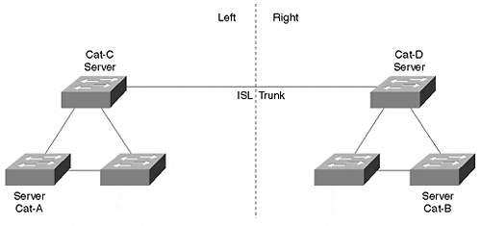
If you make any changes to the VLAN list on any server in the network, the change gets distributed to the other Catalysts in the management domain. But what happens if you make changes while the network is partitioned? For example, assume in Figure 12-13 that the trunk link between Cat-C and Cat-D servers isolate the three Catalysts on the left from the three on the right. All Catalysts should have the same VTP configuration revision number, N. See Table 12-4 for VLAN table and VTP configuration revision numbers for these steps.

Table 12-4. Synchronization Problem with Partitioned Catalysts
Step | Event | Left Catalysts |  |  | Right Catalysts
 |  | VLANs | Rev.# | VLANs | Rev.#
1 | Initial state | 1, 2, 3, 4, 5 | N | 1, 2, 3, 4, 5 | N
2 | Partition network between Cat-C and Cat-D | 1, 2, 3, 4, 5 | N | 1, 2, 3, 4, 5 | N
3 | Create VLAN 10 in left portion | 1, 2, 3, 4, 5, 10 | N+1 | 1, 2, 3, 4, 5 | N
4 | Delete VLAN 5 in right portion | 1, 2, 3, 4, 5, 10 | N+1 | 1, 2, 3, 4 | N+1
5 | Restore link between Cat-C and Cat-D | 1, 2, 3, 4, 5, 10 | N+1 | 1, 2, 3, 4 | N+1
6 | Delete VLAN 5 in left portion | 1, 2, 3, 4, 10 | N+2 | 1, 2, 3, 4, 10 | N+2
While the network is partitioned, an administrator on the left creates a new VLAN thinking, "When the network recovers, the new VLAN will get distributed to the Catalysts on the right." At the same time, an administrator on the right makes a VLAN change by deleting a VLAN. This administrator thinks like the first administrator and expects VTP to propagate the deletion when the network recovers.
When the trunk link between Cat-C and Cat-D is restored, both Catalysts issue VTP summary advertisements announcing a configuration revision update of N+1. Catalysts in each half compare the number with their own values, see that they match, and never issue a VTP advertisement request. This leaves the two portions with unsynchronized VLAN tables as shown in Step 5. To resynchronize the tables, the administrator needs to enter a VLAN modification as in Step 6, which forces an increment in the revision number. The Catalyst where the configuration change was made then issues a VTP summary advertisement and a VTP subset advertisement. This information gets distributed to the other Catalysts in the network synchronizing the VLAN tables.
A more severe case can occur when two normally isolated portions merge. Suppose the three Catalysts on the left belong to one corporate department (Engineering) that doesn't like the corporate division using the three Catalysts on the right (Marketing). The Catalysts remain isolated until a higher level manager mandates that the two divisions need to connect their networks. It is decided ahead of time by the manager that the two groups will change their domain names to a new third name so that they all belong to the same management domain. The two groups now have a configuration as shown in Step 1 of Table 12-5. (The configuration revision number was arbitrarily selected for this example.)

Table 12-5. A Catastrophic Merger of VTP Domains
Step | Event | Left Catalysts |  | Right Catalysts
 |  | VLANs | Rev.# | VLANs | Rev.#
1 | Initial state | 1, 2, 3, 4, 5 | 32 | 1, 10, 20, 30 | 57
2 | Merge domains | 1, 10, 20, 30 | 57 | 1, 10, 20, 30 | 57
The big moment arrives when the two groups shake hands and join the networks. What happens? Disaster. Because the Marketing side has a higher configuration revision number than the Engineering side, VTP updates the Engineering VLAN tables to match the Marketing side. All of the Engineering users that were attached to VLANs 2, 3, 4, and 5 now attach to ports in suspended mode. Marketing just torpedoed the Engineering LAN! Now engineering is really mad at Marketing.
Tip
Before merging different domains, be sure to create a super set of VLANs in both domains to prevent VLAN table deletion problems. Make sure that all partitions have a complete list of all VLANs from each partition before joining them together.

Similarly, if you have a Catalyst dedicated to you for playing around, and you attach it to the production network, you might delete the VLANs in your production network if you are not careful. Make sure that you either clear config all, change the VTP domain name, or put it in transparent mode before attaching it to the production network.
Tip
Another real-world situation exists that could delete VLANs in your network. If you replace a failed Supervisor module on a Catalyst configured in the server mode, you run the possibility of deleting VLANs if the new module has a higher configuration revision number than the others in the domain. Be sure to reset the configuration revision number on the new module before activating it in the system.

Broadcast Flooding
Another issue involves trunks and VTP. Chapter 8 described trunks and the syntax to establish trunks. Whenever you enable a trunk, the trunk, by default, transports traffic for all VLANs. This includes all forwarded and flooded traffic. If you have a VLAN that generates a high volume of flooded traffic from broadcasts or multicasts, the frames flood throughout the entire network. They even cross VTP management domains. This can have a significant impact on your default management VLAN 1. Refer to Chapters 15, "Campus Design Implementation," and 17, "Case Studies: Implementing Switches," for discussions on cautions and suggestions regarding the management VLAN. In Figure 12-14, a Catalyst system has trunk and access links interconnecting them. PC-1 in the system attaches through an access link assigned to VLAN 2. This particular station generates multicast traffic for video distribution on VLAN 2. The network administrator dedicated VLAN 2 to this application to keep it separate from other user traffic. Although the administrator managed to keep any of the multicast traffic from touching Cat-A and Cat-B, it still touches all of the other Catalysts in the network, even though VLAN 2 is not active in Domain 2. Why doesn't the multicast traffic bother Cat-A and Cat-B? Cat-A and Cat-B do not see the traffic from PC-1 because all of the links to these units are access links on different VLANs.

Figure 12-14 Flooding in a Multiple Domain Network
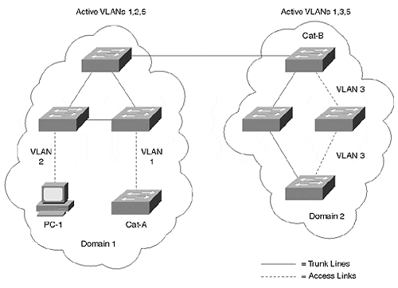
There are methods of controlling the distribution of flooded traffic throughout the network. These methods include the features of VTP pruning to control flooding, and modifications to the multicast behavior through Cisco Group Management Protocol (CGMP). VTP pruning is discussed in the section in this chapter, "VTP Pruning: Advanced Traffic Management." Details on controlling multicast with CGMP is described in Chapter 13, "Multicast and Broadcast Services."

Excessive STP
A related issue with VTP and trunking is the universal participation in Spanning Tree by all Catalysts in the network for all VLANs. Whenever you create a new VLAN, the Catalysts create a new instance of Spanning Tree for that VLAN. This feature, Per-VLAN Spanning Tree (PVST), allows you to optimize the Spanning Tree topology individually for each VLAN. All Catalysts, by default, participate in PVST. But as in the case of flooding traffic in the network, each additional instance of Spanning Tree creates additional Layer 2 background traffic. The additional traffic comes from the BPDUs distributed for each VLAN's instance of Spanning Tree. Not only does this add traffic to each link, it also requires more processing by each Catalyst. Each Catalyst must generate and receive hello messages at whatever interval is specified by the hello timer, which is every two seconds by default. And, each Catalyst must calculate a Spanning Tree topology for each VLAN whenever there is a Spanning Tree topology change. This, too, temporarily consumes CPU cycles with a complex Spanning Tree topology.

Bottom line: Controlling VTP in Large Networks
In large networks, these issues multiply and can develop into situations making you want to disable trunking, VTP, or other aspects of VLANs. Clearly, trunking remains as a necessary element of networking life. It is not practical to deploy a large network without trunks because of the number of resources that you consume with multiple access links. Therefore, trunks remain. However, as previously mentioned, we have methods of minimizing some of the negative side effects of trunking.
VTP is also an ever present part of networking with Catalysts whenever you enable trunks. You cannot disable VTP (the closest thing to an exception is Catalysts configured in transparent mode). Therefore, you need to be very careful in how you partition your management domains, who can modify the domains, what components listen to VTP, as well as in how many Catalyst switches are defined as VTP Servers in the network to limit the possibility of mistakes made by an administrator that might cause a major change in other Catalyst switches. As discussed previously, a major concern when deploying large Catalyst networks is the risk of VLAN table deletion. Intended to simplify configuration issues, it can turn against you if not carefully managed.
Tip
If you have a fairly static network where you are not adding or deleting globally significant VLANs, consider using the transparent mode to prevent erroneous actions from deleting your VLANs. However, setting up a unit in transparent mode does increase your administrative burden.

VTP V2
With the introduction of Token Ring switching in the Catalyst, Cisco updated the VTP protocol to version 2. By default, Catalysts disable VTP version 2 and use version 1. As an administrator, you need to select which version of VTP to use and ensure that all Catalysts in the VTP management domain run the same version.
VTP version 2 assists Token Ring VLANs by ensuring correct Token Ring VLAN configuration. If you plan on doing Token Ring switching, you MUST use VTP version 2 so that processes like DRiP operate. Chapter 3, "Bridging Technologies" describes DRiP in more detail.
Tip
VTP version 2 adds functionality over VTP version 1, but uses a modified form of the protocol. Version 1 and version 2 cannot coexist in the same management domain. All Catalysts in a management domain must run a homogenous VTP version to function correctly.
If you enable VTP version 2 on a Catalyst, all VTP version 2 capable Catalysts in the management domain automatically enable VTP version 2. Not all Catalysts support VTP version 2, nor do all releases of the Supervisor engine software. If you elect to use VTP version 2, ensure that all Catalysts in the domain are VTP version 2 capable.

Support for Token Ring is not the only feature added in VTP version 2, but it is the principle one.
To enable VTP version 2, use the command set vtp v2 enable.
Verify that you correctly changed it with the show vtp domain command.
Example 12-8 shows a Catalyst configured for VTP version 2 and the corresponding output from the show vtp domain command. Note the warning whenever you attempt to enable version 2 that all Catalysts in the management domain must support version 2. When you enable version 2, all Catalysts in the management domain enable version 2. Note in Figure 12-8 that there are two columns related to the VTP version. One column is titled VTP Version and the other V2 Mode. VTP Version identifies what version of VTP your code supports, but does not indicate what is currently in use. Even if you use VTP version 1, this value still shows a 2 because you have the possibility of enabling version 2. The other column on the other hand, V2 Mode, indicates what VTP version you currently enabled. If you have the default version 1 enabled, then this column indicates disabled as seen in Figure 12-6.

Example 12-8 Configuring a Catalyst for VTP Version 2
Console> (enable) set vtp v2 enable This command will enable the version 2 function in the entire management domain. All devices in the management domain should be version2-capable before enabling. Do you want to continue (y/n) [n]? y VTP domain wally modified Console> (enable) show vtp domain Domain Name Domain Index VTP Version Local Mode Password -------------------------------- ------------ ----------- ----------- ---------- wally 1 2 server - Vlan-count Max-vlan-storage Config Revision Notifications ---------- ---------------- --------------- ------------- 10 1023 1 enabled Last Updater V2 Mode Pruning PruneEligible on Vlans --------------- -------- -------- ------------------------- 10.0.0.1 enabled disabled 2-1000 Console> (enable)

VTP Pruning: Advanced Traffic Management
A transparent bridge handles LAN frames by filtering (dropping), forwarding, or flooding. Flooding occurs whenever the bridge receives a frame with a destination MAC address for which it has no entry in its bridging table. This happens whenever the bridge never hears from the destination and, therefore, has no entry in the bridge table. Or, no entry can exist because the bridge's aging timer expired for the MAC address. Frames in these scenarios are unknown unicast. Bridges also flood whenever they receive a frame with a broadcast or multicast destination address. Whenever the bridge floods, it transmits the frame to all ports in the broadcast domain (except for the source port) including trunk ports. Trunks by default transport traffic for all VLANs unless you restrict the authorized VLAN list with the clear trunk VLAN# command. This command statically defines the VLANs not allowed to transport over the trunk. The Catalyst has features to control flooding of unknown unicast, broadcast, and multicast frames. This section covers the control of unknown unicast and broadcast flooding. Chapter 13 discusses the control of multicast and broadcast flooding. The other bridging modes, forwarding and filtering, continue to operate in standard bridging fashion.
Bridges flood to increase the probability of the frame reaching the destination, even though the bridge doesn't know where the destination lives. (The other reason bridges flood is because the standards tell them to.) If the destination is alive and well in the broadcast domain, the frame should reach the destination.
Whenever the Catalyst floods the frame, it sends the frame out all trunk ports. Figure 12-15 shows a system with pruning disabled. When PC-1 generates a frame that Cat-A decides to flood, Cat-A sends the frame out all ports. The flooded frame reaches Cat-B which also decides to flood out all ports. Eventually, the flooded frame reaches all Catalysts in the trunk network including Cat-C. Note, however, that PC-1 belongs to VLAN 2. But there are no members of VLAN 2 in Cat-C; yet the flooded traffic crosses all of the trunks and eventually hits Cat-C. This consumes bandwidth on the trunks and consumes bandwidth in the Catalyst's backplane. (Cat-C discards the frame after the frame crosses the backplane.)

Figure 12-15 Flooding in a Catalyst Network Without Pruning
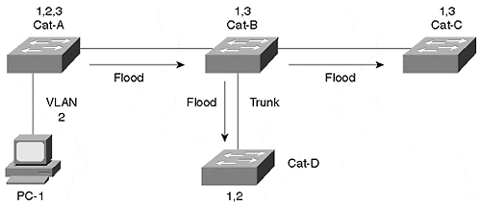
VTP pruning limits the distribution of the flooded frames to only those Catalysts that have members of VLAN 2. Otherwise, the sending Catalyst blocks flooded traffic from that VLAN.
Cisco introduced VTP pruning with Supervisor engine software release 2.1 as an extension to VTP version 1. VTP pruning defines a fourth VTP message type which announces VLAN membership. Whenever you associate Catalyst ports to a VLAN, the Catalyst sends a message to its neighbor Catalysts informing them that they are interested in receiving traffic for that VLAN. The neighbor Catalyst uses this information to decide if flooded traffic from a VLAN should transit the trunk or not.
An administrator enables pruning in Figure 12-16. When PC-1 generates a broadcast frame with pruning enabled in the Catalysts, the broadcast does not reach Cat-C as it did in Figure 12-15. Cat-B receives the broadcast and normally floods the frame to Cat-C. But Cat-C does not have any ports assigned to VLAN 2. Therefore, Cat-B does not flood the frame out the trunk toward Cat-C. This preserves bandwidth on the trunk and on the Catalyst's backplane.

Figure 12-16 Flooding with VTP Pruning Enabled
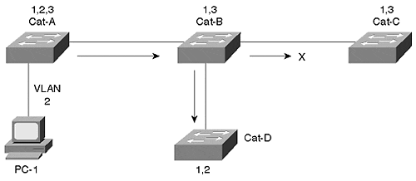

Configuring VTP Pruning
You can enable VTP pruning with the command set vtp pruning enable. By default, this enables the Catalyst to prune all VLANs. But you can elect to prune only a couple of VLANs. Then, you can modify the prune list by first clearing the list with the command clear vtp pruneeligible vlan_range. Next, you can specify which VLANs to prune with the related command, set vtp pruneeligible vlan_range.
Example 12-9 shows a session where an administrator enables pruning, but then modifies the list of pruning eligible VLANs. When you initially enable pruning, the Catalyst considers all VLANs as pruning eligible. The administrator then specifies VLANs 10-20 as pruning ineligible. This means that any flooded traffic in these VLANs propagate to all Catalysts, even if there is no member of the VLAN on the receiving Catalyst. Note that the default VLANs 1, 1001–1005 are always pruning ineligible. Finally, the administrator restores VLAN 15 as pruning eligible. The show vtp domain output in Example 12-9 confirms pruning as enabled and further confirms the list of pruning eligible VLANs. (See the highlighted fields on the output.)

Example 12-9 Configuring VTP Pruning
Console> (enable) set vtp pruning enable This command will enable the pruning function in the entire management domain. All devices in the management domain should be pruning-capable before enabling. Do you want to continue (y/n) [n]? y VTP domain wally modified Console> (enable) clear vtp pruneeligible 10-20 Vlans 1,10-20,1001-1005 will not be pruned on this device. VTP domain Lab_Network modified. Console> (enable) set vtp pruneeligible 15 Vlans 2-9,15,21-1000 eligible for pruning on this device. VTP domain Lab_Network modified. Console> (enable) show vtp domain Domain Name Domain Index VTP Version Local Mode Password -------------------------------- ------------ ----------- ----------- ---------- wally 1 2 server - Vlan-count Max-vlan-storage Config Revision Notifications ---------- ---------------- --------------- ------------- 4 1023 10 disabled Last Updater V2 Mode Pruning PruneEligible on Vlans --------------- -------- -------- ------------------------- 10.0.0.1 disabled enabled 2-9,15,21-1000 Console> (enable)

Review Questions
This section includes a variety of questions on the topic of this chapter—VTP. By completing these, you can test your mastery of the material included in this chapter as well as help prepare yourself for the CCIE written and lab tests.
Refer to Figure 12-17 for all review questions.

Figure 12-17 For Review Questions 1–9
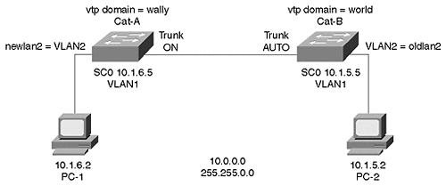
1: | In what mode is the link between the two Catalysts?
2: | Change both ends of the trunk to ON. Can PC-1 ping PC-2?
3: | Can Cat-A ping Cat-B?
4: | Can Cat-B ping PC-2?
5: | VLAN 2 used to be called oldlan2. An administrator at Cat-A renames VLAN 2 to newlan2. Does Cat-B know about the new name, newlan2?
6: | Clear config all on Cat-B. Reenter the IP address on sc0. Can Cat-B ping Cat-A?
7: | Can PC-2 ping PC-1?
8: | Does Cat-B know about newlan2?
9: | Can Cat-B remove newlan2?

